# The task

* You will create an ASP.NET web application using Visual Studio. The application will embed a Google map in a page, and display locations of Iris offices around the UK.
* The locations are stored in an XML file (included). Your solution will read this XML file to display the locations.
* In the future, the business will be storing these locations in a database. Be prepared to write your solution in such a way that it will be easy to swap out this functionality.
* Your application will compile and run, and display a Google map of the locations included in the file.

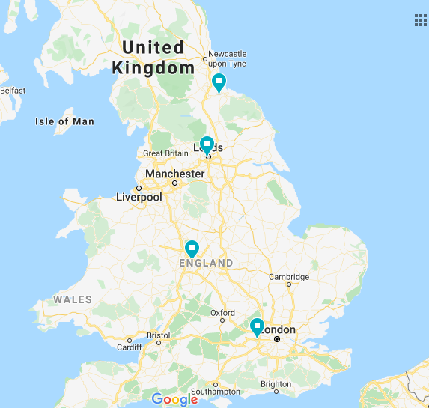

# The evaluation

* The evaluation **will not be quantitative** e.g. a mark out of 10.
* The evaluation during the interview will be a conversation around your understanding of the problem, you approach, your approach in a real world environment and any challenges you faced.

# Timing

Try to limit your time on the task to no more than an hour, since the discussion is not based around the quantity of work produced. You should do enough to be able to run the application and explain your reasoning of the problem and what you would do given more time.

# The resources included

* An XML file with Iris locations
* Google Maps API Key : XXXXXXXXXXXXXXXXXXXXXX